**DAILY ONLINE ACTIVITIES SUMMARY**

|  |  |  |  |  |  |  |  |  |
| --- | --- | --- | --- | --- | --- | --- | --- | --- |
| **Date:** | **09/06/2020** | | | | | **Name:** | **Katira Krishna J** | |
| **Sem & Sec** | **8th A** | | | | | **USN:** | **4AL16CS045** | |
| **Online Test Summary** | | | | | | | | |
| **Subject** | | **BDA** | | | | | | |
| **Max. Marks** | | **30** | | **Score** | | | **26** | |
| **Certification Course Summary** | | | | | | | | |
| **Course** | **Introduction to Data Science** | | | | | | | |
| **Certificate Provider** | | | **Cognitiveclass.ai** | | **Duration** | | | **3 hours** |
| **Coding Challenges** | | | | | | | | |
| **Problem Statement: Python program to calculate the number of digits and letters in a string** | | | | | | | | |
| **Status: Completed** | | | | | | | | |
| **Uploaded the report in Github** | | | | | **yes** | | | |
| **If yes Repository name** | | | | | **Krishna_Katira** | | | |
| **Uploaded the report in slack** | | | | | **yes** | | | |

Online Test Details:

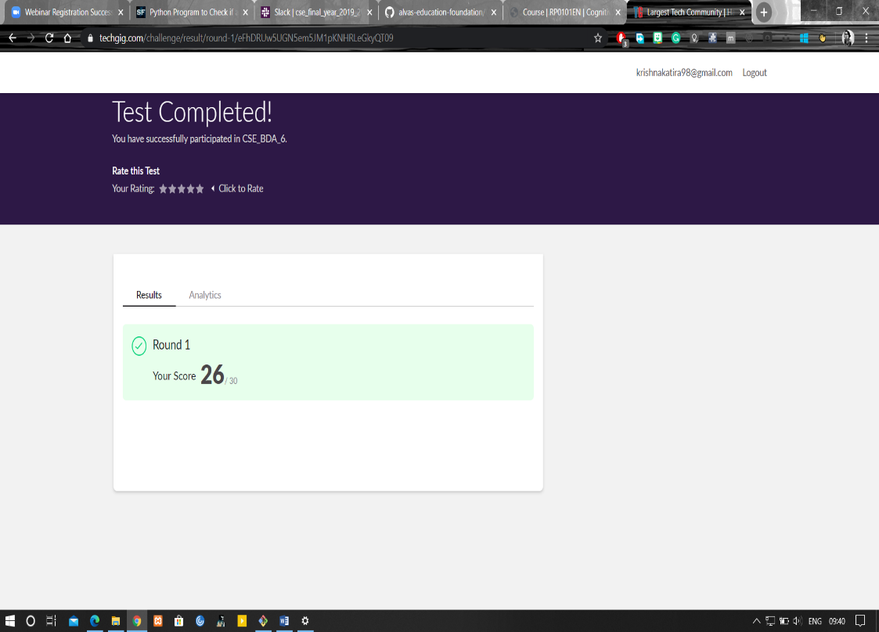

Certification Course Details:

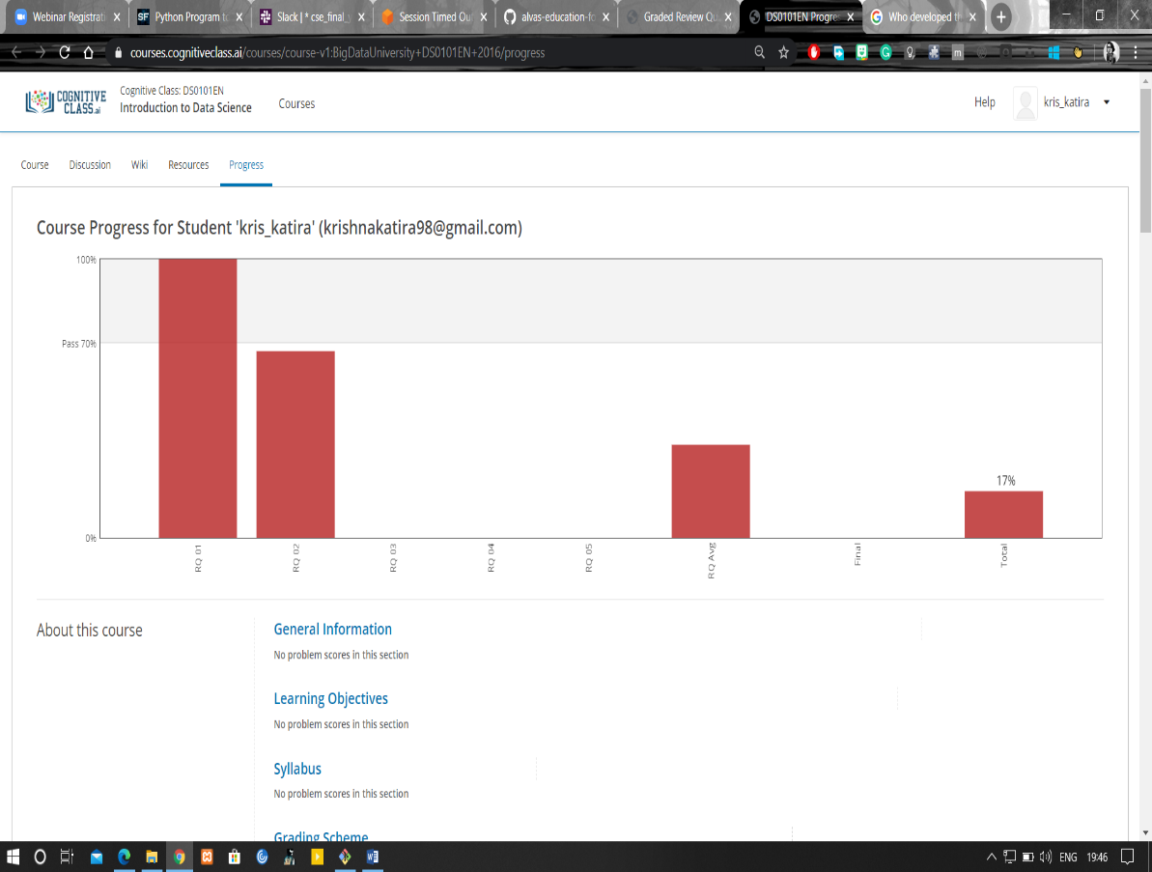

Coding Challenges Details:

**Program:**

string=raw_input("Enter string:")

count1=0

count2=0

for i in string:

if(i.isdigit()):

count1=count1+1

count2=count2+1

print("The number of digits is:")

print(count1)

print("The number of characters is:")

print(count2)